DR. SAMSON A. OGOLA, DBA, MBA,MSC
Executive Technology Leader | CIO | CTO | AI Strategist | Higher Education Faculty
Tyngsboro, MA | 978-967-0052 | sadada2008@gmail.com | LinkedIn: linkedin.com/in/samogola

Executive Summary
Technology executive, educator, and AI strategist with 20+ years of experience leading digital transformation, healthcare IT, enterprise infrastructure, cybersecurity, cloud computing, artificial intelligence initiatives, and higher education programs. Proven success managing large-scale technology portfolios, Epic deployments, multinational projects, AI-driven solutions, and cross-functional teams.

Career Highlights
- Led Epic-related technology initiatives supporting approximately 15,000 devices across Tufts Medicine.
- Directed multinational technology projects spanning 15 African countries.
- Established 13 data centers and supported deployment of enterprise information systems.
- Led AI, cloud, cybersecurity, and digital transformation initiatives.
- Managed cross-functional technology teams and enterprise stakeholders.
- Faculty member and curriculum contributor in information technology, cybersecurity, business, and AI.

Core Competencies
Artificial Intelligence • Machine Learning • Digital Transformation • Cloud Computing (AWS, Azure, GCP) • Cybersecurity • Enterprise Architecture • Healthcare IT • Epic Systems • Project Portfolio Management • Data Analytics • Business Intelligence • IT Governance • Higher Education Technology • Strategic Leadership

Education
- Doctor of Business Administration, William Howard Taft University (2021)
- Master of Science in Applied Artificial Intelligence, Eastern University (2026 - 2027)
- Master of Computer Science, Atlanta College of Liberal Arts and Sciences (2025)
- MBA, Strategic Management, Maseno University, Kenya (2010)
- BSc Information Technology, Jomo Kenyatta University of Agriculture and Technology, Kenya (2007)

Certifications
AWS Certified Security – Specialty  Account ID 4750-5641-2927  This Certification provided me with in-depth understanding of AWS security services and the shared responsibility model (between AWS and the customer). I demonstrated the ability to design, implement, and troubleshoot various security models in the AWS Cloud. As a Badge owner I can leverage various security models for organizations of all sizes. | 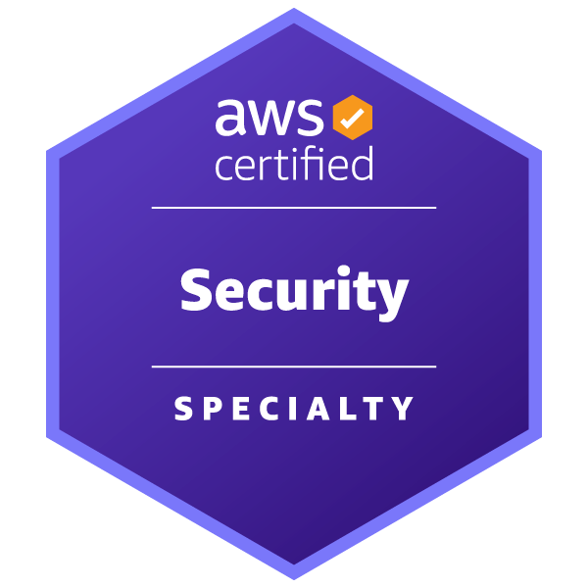
AWS Certified Solutions Architect – Associate  Account ID 4750-5641-2927  I have a comprehensive understanding of AWS services and technologies. I have demonstrated the ability to build secure and robust solutions using architectural design principles based on customer requirements. I am able to strategically design well-architected distributed systems that are scalable, resilient, efficient, and fault tolerant. | 
Google/Gies College of Business Dual Credential  Google/Gies College of Business dual credential completed both the Google IT Support Certificate and the Professional Success Skills Certificate from Gies College of Business at the University of Illinois Urbana-Champaign. They are competent in foundational IT skills, including troubleshooting and customer service, networking, operating systems, system administration, and security, and in skills like decision-making, creative problem-solving, communication, and leadership | 
CompTIA A+ Core 1 & 2  A+ builds foundational skills in hardware, software, networking, troubleshooting, and security | 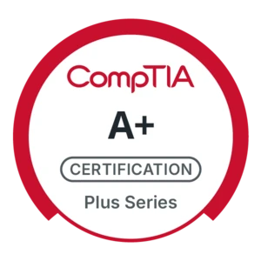
Network+  This was a premier certification for validating my knowledge of essential networking tools and concepts | 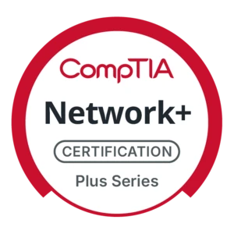

Other Certifications
Senior Management Course- Kenya School of Government
Government Humna Resource Information Systems

Professional Experience

Chief Technology Officer & Founding Member,

Nova Analytics International (2024–Present)
- Lead AI strategy, analytics platforms, and machine learning initiatives.
- Guide organizations through AI adoption and digital transformation.
- Design scalable cloud-based AI architectures and governance frameworks.

Founder & President
St. Thomas Aid Initiative- Kenya | 2020–Present
- Provide strategic leadership for education, healthcare, and community development programs.
- Lead fundraising, stakeholder engagement, and partnership development with government and nonprofit organizations.
- Direct community outreach initiatives focused on poverty alleviation and social impact.
- Manage volunteers, program teams, and organizational growth initiatives.
- Expanded educational support and healthcare programs serving vulnerable populations across Kenya.

Information Technology Project Manager
Tufts Medicine | 2021–2024
- Managed enterprise healthcare technology projects supporting Epic deployments across multiple facilities.
- Coordinated rollout and migration activities involving approximately 15,000 devices.
- Led stakeholder communications, project planning, risk management, and implementation activities.
- Supported infrastructure modernization and healthcare automation initiatives.
- Ensured project delivery through schedule management and cross-functional collaboration.

Technical Customer Services
Amazon | 2018–2021
- Delivered advanced technical support for customers and enterprise systems.
- Resolved complex hardware, software, and network issues while maintaining high customer satisfaction.
- Maintained asset inventories and supported infrastructure operations.
- Served as liaison between customers and technical teams to ensure timely issue resolution.
- Improved service quality through effective troubleshooting and customer engagement.

System Support Engineer
Worldwide Tech Services | 2017–2018
- Implemented and supported Windows and Linux server environments.
- Installed and maintained data center infrastructure and IP network systems.
- Provided hardware and system support across multiple platforms and vendors.
- Delivered technical solutions resulting in high operational performance and customer satisfaction.

Regional Information Technology Manager
Regional Center on Small Arms (2010–2016
- Led multinational technology projects across 15 African countries.
- Directed deployment of enterprise information systems and establishment of data centers.
- Managed infrastructure projects, training programs, and regional IT teams.
- Coordinated stakeholder engagement and technology governance initiatives.
- Supported digital transformation and capacity-building programs across member states.

Faculty Lecturer
Maseno University | 2009–2016
- Taught undergraduate and graduate courses in information technology, computer science, business, and management.
- Developed curricula, instructional materials, and assessment strategies.
- Supervised research projects and mentored students on academic and career development.
- Participated in academic committees and interdisciplinary collaborations.
- Integrated educational technologies and innovative teaching approaches into course delivery.

Senior Lecturer
Kenya School of Government | 2012–2015
- Delivered executive training programs for government officials in strategic management, ICT, public administration, and organizational development.
- Developed curricula, training manuals, and instructional resources.
- Conducted research, consultancy activities, and capacity-building initiatives.
- Coordinated training programs and evaluated learning outcomes.
- Facilitated classroom and distance-learning programs for public sector professionals.

Faculty Lecturer
Jomo Kenyatta University of Agriculture and Technology (JKUAT) | 2007–2012
- Delivered courses in programming, networking, cybersecurity, web development, and information systems.
- Developed course materials, assessments, and instructional plans.
- Supervised student projects and provided academic advising.
- Conducted research and collaborated with faculty across disciplines.
- Leveraged instructional technologies to enhance teaching and student engagement.

